FOOD GUIDE
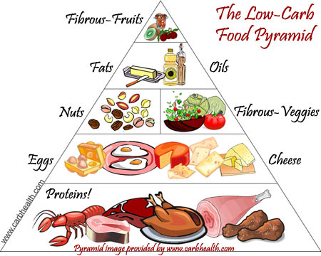
WATER! WATER! WATER!
Below is a great source for understanding the importance of water! http://www.drstandley.com/food_water.shtml
EXERCISE! EXERCISE! EXERCISE!
LESS PROCESSED FOODS!
DOs | DON’TS
+Water  +Coconut Water  +Homemade Lemonade | -Sodas  -Diet Soft drinks  -Alcohol-
+Almond milk  +Rice milk  +Coconut milk  +Soy milk | -Vitamin D milk  -Skim milk  -2% milk
+Barley Malt  +Organic Agave  +Honey  +Pure Maple Syrup | -White processed sugar  -Brown Sugar  -Powdered Sugar  -Artificial Sweetners (e.g., Splenda, Equal)
+Sea Salt | -White Salt
+Organic Virgin Coconut Oil  +Organic Olive Oil | -Vegetable Oil
+UnBleached Flour | -Bleached Flour
+Brown Rice | -White Rice
+White Meat, Turkey, Chicken | -Dark Meat, Pork, Ribs, Steak
+Salmon, Tuna | -Shrimp, Scallop, Crab
+Bake, Cook,Grill | -Fried
Remember to take your vitamins!
This is intended only as an informative guide and is in no way intended to replace a qualified doctor’s or physician’s recommendations. The author shall have neither liability nor responsibility to any person or entity with respect to any loss or damage for any consequences arising out of the use of this guide.

