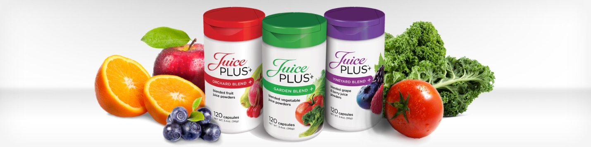

The Next Best Thing to Fruits and Vegetables
Juice Plus+ is whole food based nutrition, including juice powder concentrates from 25 different fruits, vegetables and grains.
Everyone wants to eat right and maintain a healthier lifestyle - whether you're a busy mom hustling to feed on-the-go children, a business traveler trying to stay fit, or an active boomer keeping up with grandkids.
All of us try to eat better for good health, but a healthy diet is often a challenge. We simply don't eat enough fruits and vegetables. And that hurts our health and wellness.
Juice Plus+ helps bridge the gap between what you should eat and what you do eat every day.
Not a multivitamin, just simply fruits and vegetables that have been processed by Instant Quick Freezing (IQF) and is all-natural and made from quality ingredients carefully monitored from farm to capsule so you can enjoy improved nutrition and wellness.
Try Juice Plus+ today by contacting one of the representatives below:
Deborah Womack Damaris Davis
www.dwomack.juiceplus.com www.damaris.juiceplus.com
(202) 329-1350 (301) 651-1566

